Name: s. devi
Domain: Data analytics
Project: milestone project 1
Advanced data analysis and visualization using Microsoft excel
I collected the dataset from kaggle

Airline Ticket Price Analysis and Prediction

Introduction
This project focuses on analyzing airline data using Excel. The dataset was organized into multiple tables and connected through power pivot relationships to maintain accuracy and avoid duplication.

Aim
To organize and analyze airline data using excel tools to find trends and support decision-making.

Project Workflow

Data collection-Import airline data from different sources into excel.
Data Cleaning-Remove duplicate,fix missing values, and format the dataset.
Data modeling-create power pivot relationships between tables using key fields.
Lookup Functions-Use Vlookup and Xlookup with IFERROR to retrieve accurate data.
Analysis-build pivot tables to summarize trends and performance.
Visualization-Create dashboards and charts to display key insights clearly.

Data Understanding
Data Size: 800 rows and 12 columns
Column Types: (column name, data type, description) Types:(Airline, Text, Name of the airline, Flight Number (Numeric))
Initial Observations: No Major missing values after cleaning. Some flights have multiple stops which affect ticket prices. Ticket prices vary by airline, seat class, and stops.

Data Cleaning
Handling missing values : Verified the dataset no duplicate rows were found.
Missing values : Checked all columns no missing values were found.
Inconsistent records: Standardized Airline, seat class, and city names to ensure uniform spelling and capitalization.

Derived Metrics
Definition: Derived metrics are new columns or fields created by transforming or combining existing data to support deeper analysis.
Helps identify trends and patterns not immediately visible in a raw data.
Examples: Flight ticket price comparison airline Airindia and sum of price and count of class.

Filtering /Segmentation
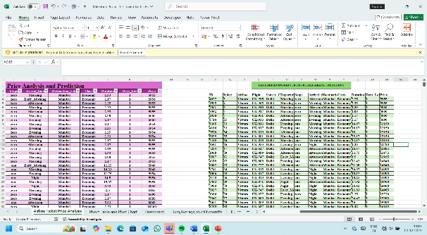
Filter flights by Airline, seat class, Source city, destination city to compare price patterns. Example: Vistara has long data because it operates many routes and flight types.

Statistical/formula-Based Analysis
Use excel formulas such as Sum, Average, to calculate key metrics like average ticket Price example: =Average(Y7:Y46)
Apply COUNTIF and COUNTIFS to measure frequency. Example:=Countif(B2:B101,”Air India”) 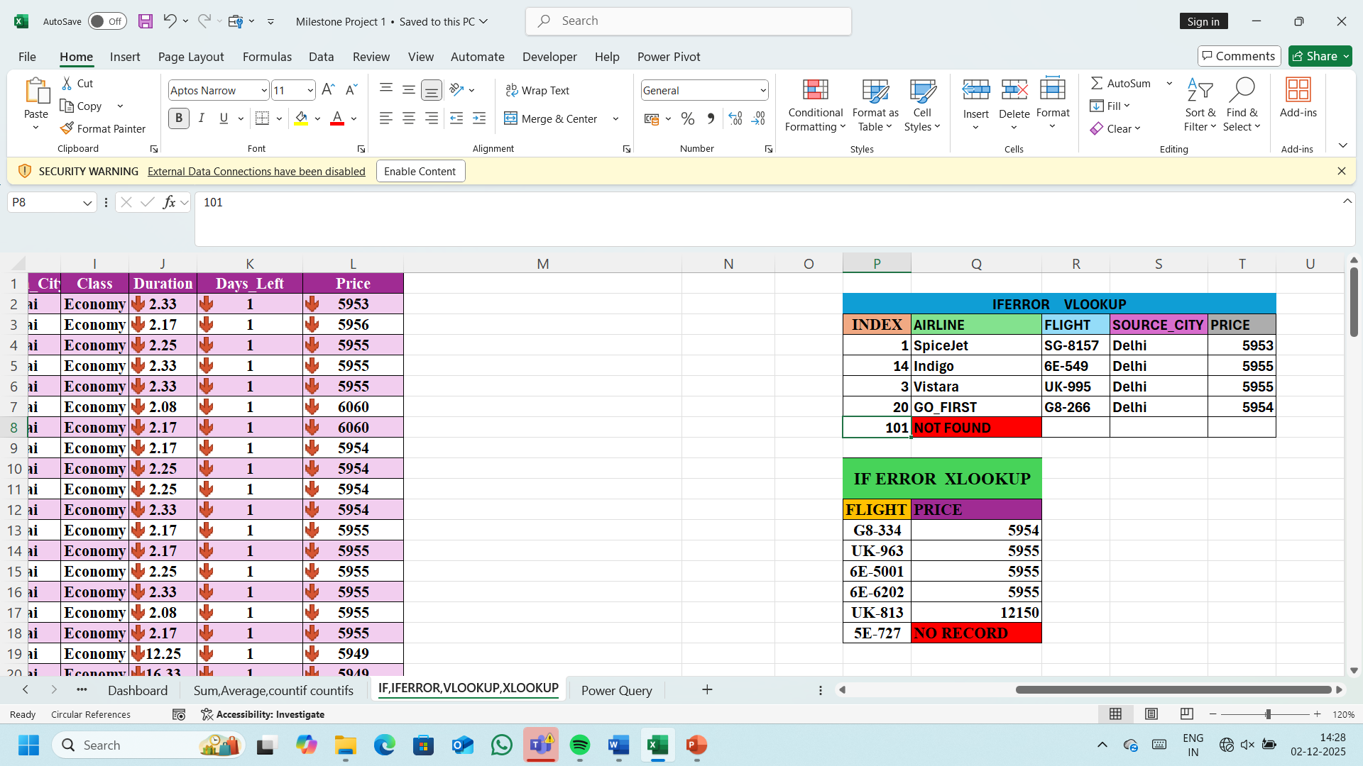
If, Iferror, Vlookup,Xlookup help retrieve accurate values, handle invalid records, and avoid formula errors.

EDA (Pivot tables, Pivotcharts, visualization)

Univariate Analysis: Examines one variable at a time (example:Ticket price, source city)
Use pivot table to calculate averages, maximum, minimum, and frequency counts.
Bivariate Analysis: compares two variables together (Examples:Airline Vs Ticket price)
Multivariate Analysis:
Analyzes three or more variables at the same time. Example: Airline+source city+destination city in a pivot table. Use slicers, filters and dashboards to view segment-based trends and decision-making insights.

Scenario Analysis

Used to test how changes in input values (ticket price) example: adjust the percentage increase in demand to see how it changes average ticket price or total revenue. 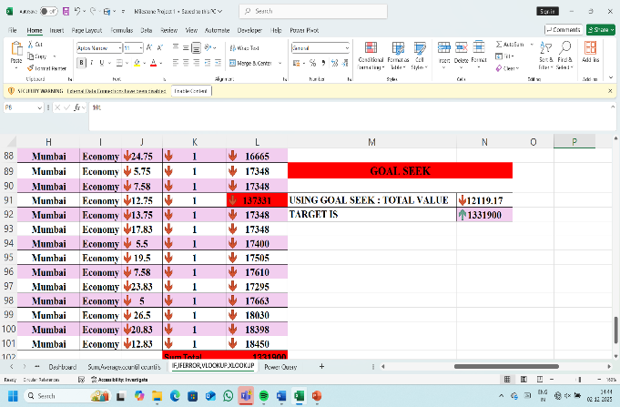
Goal Seek: Use to reverse-calculate a required input to achieve a specific targe output. Example: find the ticket price required to reach a certain revenue target for Airline.

Insights
Vistara shows consistently higher ticket prices, especially for economy classes.
AirAsia provides lower-cost options, making it more affordable on short routes and domestic flights.

Conclusion
The project successfully organized the dataset using power pivot relationships and lookup functions. With pivot tables and dashboards, the data become easier to analyze, allowing clear trends and key insights for decision-making.

